Web address: www.yarrame.vic.edu.au
Email: yarra.me.sch@education.vic.gov.au
ABN: 32 453 166 084

Attach Student Photo
YARRAME SCHOOL
INTAKE PROGRAM
STUDENT REFERRAL 2024

DATE OF REFERRAL

REFERRING SCHOOL:
SCHOOL ADDRESS:
PHONE NO: |  | EMAIL:
SCHOOL CONTACT:
ROLE AT SCHOOL: |  | DIRECT NO:
CURRENT CLASSROOM TEACHER/S
NAME |  | CONTACT INFORMATION

STUDENT NAME:
CURRENT YEAR LEVEL: |  | GENDER:
2024 YEAR LEVEL: |  | DATE OF BIRTH:
IS THE STUDENT OF ABORIGINAL OR TORRES STRAIT ISLANDER ORIGIN?
HOME ADDRESS:
PARENT/CARER 1: |  | DIRECT PH NO:
RELATIONSHIP: |  | EMAIL:
PARENT/CARER 2: |  | DIRECT PH NO:
RELATIONSHIP: |  | EMAIL:
PREVIOUS SCHOOL:
(IF APPLICABLE)

PROGRAM
YarraMe School provides Social and Emotional Learning Intensive programs that are personalised for each student. This is done in partnership with the referring school using a multidisciplinary intervention approach.

Please see our website www.yarrame.vic.edu.au for a description of the programs and referral criteria.

TO BE COMPLETED BY THE REFERRING SCHOOL
- REASONS FOR REFERRAL.:
DESCRIPTION OF CONCERNS SCHOOL / HOME:

IN WHAT WAYS IS IT ANTICIPATED THAT A PLACEMENT IN THE PROGRAM WILL ASSIST THE STUDENT AND THE FAMILY?

- SUPPORTS / AGENCIES:
Has the student been previously supported by YarraMe School? |  |  |  |  |  | ☐ | YES |  | ☐ |  |  |  | NO
IF YES, PLEASE INDICATE THE PROGRAM(S):

☐ | Junior Program | ☐ | Senior Program | ☐ | Outreach Coaching Service |  |  | ☐ |  |  | Standard or Extended Consultation
Has an IRIS been lodged in relation to this student’s behaviour? |  |  |  |  |  | ☐ | YES |  | ☐ |  |  |  | NO
IF YES, PLEASE PROVIDE DETAILS:
Have DE Regional staff been involved with the student? |  |  |  |  |  | ☐ | YES |  |  | ☐ |  | NO
IF YES, PLEASE PROVIDE DETAILS (NAME / DATE):
Have any suspension or expulsions occurred? |  |  |  |  |  | ☐ | YES |  |  | ☐ |  | NO
IF YES, DETAIL BEHAVIOURAL CONSEQUENCES:
OUTLINE THE STAGED RESPONSE THE SCHOOL HAS TAKEN TO SUPPORT THE STUDENT AND THE FAMILY:
Is School Wide Positive Behaviour Support (SWPBS) implemented across your school?  If No, what other behaviour frameworks do you have in place? |  |  |  |  |  | ☐ | YES |  |  | ☐ |  | NO
BEHAVIOUR PREVENTION FRAMEWORKS USED:

- ASSESSMENTS / PLANS:
Indicate Department of Education / SSS involvement including assessments:
☐ | Psychologist |  |  |  |  | ☐ |  |  |  | Paediatrician |  |  |  | ☐ |  | Speech Pathologist |  |  |  |  | ☐ |  | Occupational Therapist
OUTLINE THE STRATEGIES SUGGESTED BY DE/SSS STAFF AND THE OUTCOMES
* ATTACH REPORT
Indicate referral or assessment by other agencies, e.g. Paediatrician /MHS:
☐ |  | DFFH |  | ☐ |  |  | RCH |  |  |  |  | ☐ | MHS |  |  |  | ☐ |  | Medical Specialist |  |  | ☐ |  |  | Other
IF YES TO ANY, PLEASE PROVIDE DETAILS
(NAME / DATE):
* ATTACH REPORT
Has the student had a vision impairment test? |  |  |  |  |  |  |  |  |  |  |  |  |  |  |  |  |  | ☐ |  | YES |  |  |  | ☐ |  | NO
IF YES, DETAILS:
Has the student had a hearing impairment test? |  |  |  |  |  |  |  |  |  |  |  |  |  |  |  |  |  | ☐ |  | YES |  |  |  | ☐ |  | NO
IF YES, DETAILS:
Is the student receiving support through the Program for Students with Disabilities or Disability Inclusion?
☐ | No |  | ☐ |  | Yes |  |  | PSD Level: _____  Criteria: __________ |  |  |  |  |  |  | ☐Disability Inclusion Profile Attached  Disability Inclusion Coach contact: _____________  ______________________________________________
****PLEASE NOTE CURRENT COGNITIVE, AND SPEECH REPORTS MUST BE SUBMITTED WITH THIS REFERRAL****

- SUPPORT PLANNING:
IS THE STUDENT ABLE TO PLAY COOPERATIVELY IN THE PLAYGROUND OR DO THEY NEED ADDITIONAL SUPPORT?
ARE THERE SPECIAL ARRANGEMENTS IN PLACE TO SUPPORT THIS CHILD’S NEEDS IN THE PLAYGROUND?
Does the student have a Behaviour Support Plan/Safety Plan? |  |  | ☐ |  | YES |  | ☐ |  | NO
IF YES, DETAILS:
* ATTACH PLAN
Does the student have an Individual Learning Plan? |  |  | ☐ |  | YES |  | ☐ |  | NO
IF YES, DETAILS:
** ATTACH PLAN
Does the student have a Mental Health Plan? |  | ☐ |  | YES |  | ☐ |  | NO
IF YES, DETAILS:
* ATTACH PLAN
Does the student have a Student Support Group (SSG)? |  | ☐ |  | YES |  | ☐ |  | NO
PLEASE PROVIDE DETAILS OF COMPOSITION AND FREQUENCY OF MEETINGS:

- PERSONAL INFORMATION:
FAMILY BACKGROUND (CURRENT LIVING ARRANGEMENTS, SIBLINGS, CUSTODIAL AGREEMENTS)
LIST THE STUDENT’S STRENGTHS AND PERSONAL RESOURCES
HAS THE STUDENT’S ATTENDANCE BEEN REGULAR? PLEASE PROVIDE ATTENDANCE SUMMARY FOR THE LAST 8 WEEKS.

- MEDICAL REPORTS:
MEDICAL HISTORY /GENERAL HEALTH. (INCLUDE ANY MEDICATION THE STUDENT IS TAKING E.G RITALIN, CONCERTA,
IS THERE A MEDICAL DIAGNOSIS? E.G ASD, ADHD, ODD, OCD
Is the student in receipt of NDIS funding? |  | ☐ | YES |  | ☐ | NO
Does the student access external support services?  If yes, please list: |  | ☐ | YES |  | ☐ | NO
Does the student have a formal (multidisciplinary) ASD diagnosis?  If yes, a sensory profile completed by an occupational therapist is required to be attached. |  | ☐ | YES | ☐ |  |  | NO

- ACADEMIC:
PLEASE ATTACH COPIES OF STUDENT’S MOST RECENT ACADEMIC REPORTS
PLEASE ATTACH STUDENT WORK SAMPLES

- PARENT/GUARDIAN CONSENT:
PLEASE ATTACH A COPY OF THE SIGNED CONSENT FORM

I have read and agree with the conditions of the placement as set out in the ‘Partnering Agreement.' See sample agreement on Yarra me School website.
An administrative fee of $500 (Ex GST) per referral will be charged to the referring school.

ROLE | POSITION | SIGNATURE
PRINCIPAL NAME | SIGNATURE | DATE

UPLOAD COMPLETED REFERRAL FORMS TO:
https://www.yarrame.vic.edu.au/intake.html

Selecting either the Junior or Senior Program online form

NOTE: Please complete the Referral Checklist on the next page before lodging the referral form

Section | Documentation Required with Intake Referral
Referral Form | ☐ All sections are completed
Cognitive/WISC Assessment | ☐ Complete Cognitive Report
 | Current (less than 2 years) is attached
Speech and Language Assessment | ☐ Complete Speech and Language Report  Current (less than 2 years) is attached
ASD  Sensory Profile | ☐ Sensory Profile Report by Occupational Therapist is  attached. This is a requirement for students with a  formal ASD diagnosis
Academic Report | ☐ Most recent academic report is attached  ☐ Work sample is attached
Other assessments | ☐ If other assessments are indicated, the reports must be  included e.g medical specialist, disability inclusion profile
Attendance | ☐ An 8 week attendance summary is included
Custodial Arrangements | ☐ Copy of any custodial arrangements or intervention  orders attached
Parent/Guardian Consent | ☐ Signed consent form is attached
Signature | ☐ Principal has signed, and agreed to the conditions in  the Partnering Agreement
Please make sure you include all of the required documentation

**Referrals lodged without the above documentation cannot be processed**
 | OFFICE USE ONLY
 | ☐ All sections are complete and reports included
☐ Was the student supported in Sec. Consult, Intake or
Inclusion Support? When?
☐ If yes, file history downloaded and attached.
 | Date referral received:

Permission to share personal information for the purposes of a referral to the Yarra Me Intake Program

Yarra Me School specialises in building social and emotional development, wellbeing and engagement in education for our learners.
This is done by building student capability whilst developing the Team Around the Learner.

Personalisation, Pedagogy and Partnerships
Yarra Me School believes in the efficacy and the power of the '3Ps' - Personalisation, Pedagogy and Partnerships:
- Meeting the student at their point of need (personalisation)
- Providing reasonable adjustments (personalisation and pedagogy), whilst
- Focusing on relationship styles that support learning and healing (partnerships)
- Teacher practice (pedagogy) being:
  - ​Informed by trauma-sensitive practices (personalisation and pedagogy)
  - Supporting of behaviour change by being mindful and observant of the deeper and often hidden motivations for student behaviour

​ Yarra Me School provides:
- A classroom-based, intensive social and emotional tier 2 and 3 learning environment:
  - ​At our Preston campus
  - For 3 days a week across 2 terms
- Outreach Services to schools:
  - ​As a component of the Intake program
  - As an additional follow-up to the Intake program

​Success with Yarra Me School
Three crucial conditions must be met to achieve strong, positive and sustainable outcomes:
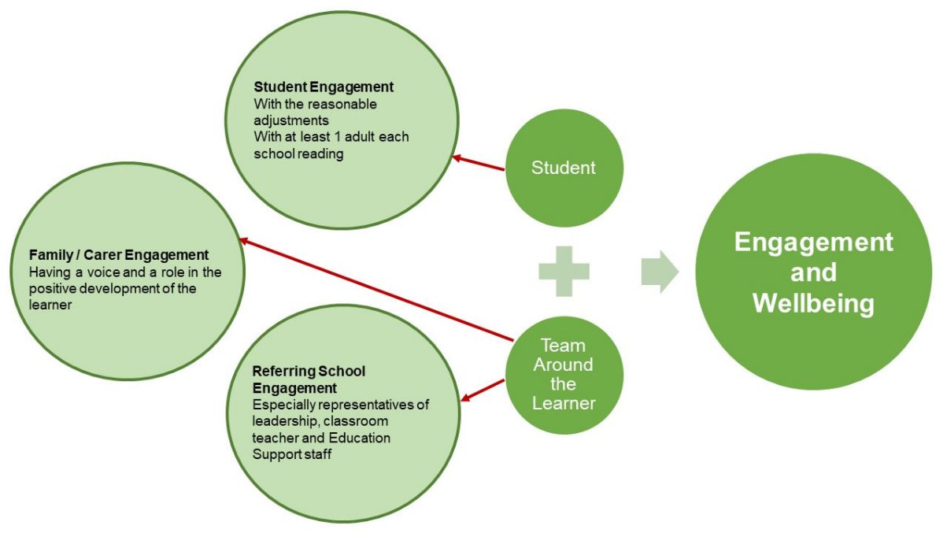

Privacy Statement
Your personal information is protected by law, including the Privacy Act 1988 (the Privacy Act). Personal information collected by Yarra Me School will be disclosed to the relevant Program Manager and intake referral committee assessing your child's referral.

Information collected and disclosed between the two schools will include:
- documentary evidence of assessments undertaken such as cognitive assessments, language assessments and occupational therapy assessments
- documentary evidence of diagnosed medical conditions, additional needs, or evidence of current and ongoing therapeutic supports; and
- other information about your child's family background that you have provided.

The Department is committed to protecting the privacy of personal information and adheres to the requirements of the Australian Privacy Principles (APPs) contained in the Privacy Act. The APPs regulate the Department’s collection, use, disclosure and management of personal information.

For further information on the Department’s privacy policy, including information on how the Department handles personal information, how you can access or correct personal information, and how to make a complaint about a breach by the Department of the APPs or a registered APP code that binds the Department, and how the Department will deal with such a complaint, go to http://www.education.gov.au/privacy. You may also request a copy of the privacy policy from privacy@dese.gov.au.

___________________________________________________________________________________

PARENT/GUARDIAN CONSENT

By signing below, I/we acknowledge that I/we have read the Privacy Statement (above) and agree for the school to disclose information about my/our child to Yarra Me School for the purposes of submitting a referral application for the Yarra Me Intake Program.

School name __________________________________
Child name ____________________________________
Date of Birth / /__ _

Parent/Guardian 1 |  | Parent/Guardian 2 (optional)
Full name |  | Full name
Relationship to child |  | Relationship to child
Signature |  | Signature
Date |  | Date

Please contact Yarra Me School on 9478 8895 if you have any further questions.

